
CAR PRICE PREDICTION PROJECT

Submitted By:
Lakshmi Rajendra Thute

ACKNOWLEDGEMENT
I am very much Thankful to FlipRobo Technologies for giving me the opportunity to work with them and to work on this project and also, I am very grateful to Data Trained Education Team for their support and help to understand each and every concept of machine learning which helped me a lot while working on this project. I thought, I am fortunate to become a part of FlipRobo Technology.

References:
Google website
Stack overflow
Analytics Vidya
Medium
Data trained notes

INTRODUCTION

With the covid 19 impact in the market, we have seen lot of changes in the car market. Now some cars are in demand hence making them costly and some are not in demand hence cheaper. One of our clients works with small traders, who sell used cars. With the change in market due to covid 19 impact, our client is facing problems with their previous car price valuation machine learning models. So, they are looking for new machine learning models from new data. We have to make car price valuation model.
For this we have to scrape the data from various used car websites such as OLX, Car Dekho, Cars24 etc. The scraped data must contain features as Brand, model, variant, manufacturing year, driven kilometres, fuel, number of owners, location and the target variable Price.

ANALYTICAL PROBLEM FRAMING

• Mathematical/ Analytical Modelling of the Problem
Here I have done Data Pre-processing, Exploratory Data Analysis, then Encoding and lastly model Building and Evaluation.

• Data Sources and their formats
I got the dataset in CSV format and I read the data in Jupyter Notebook using pandas data frame.

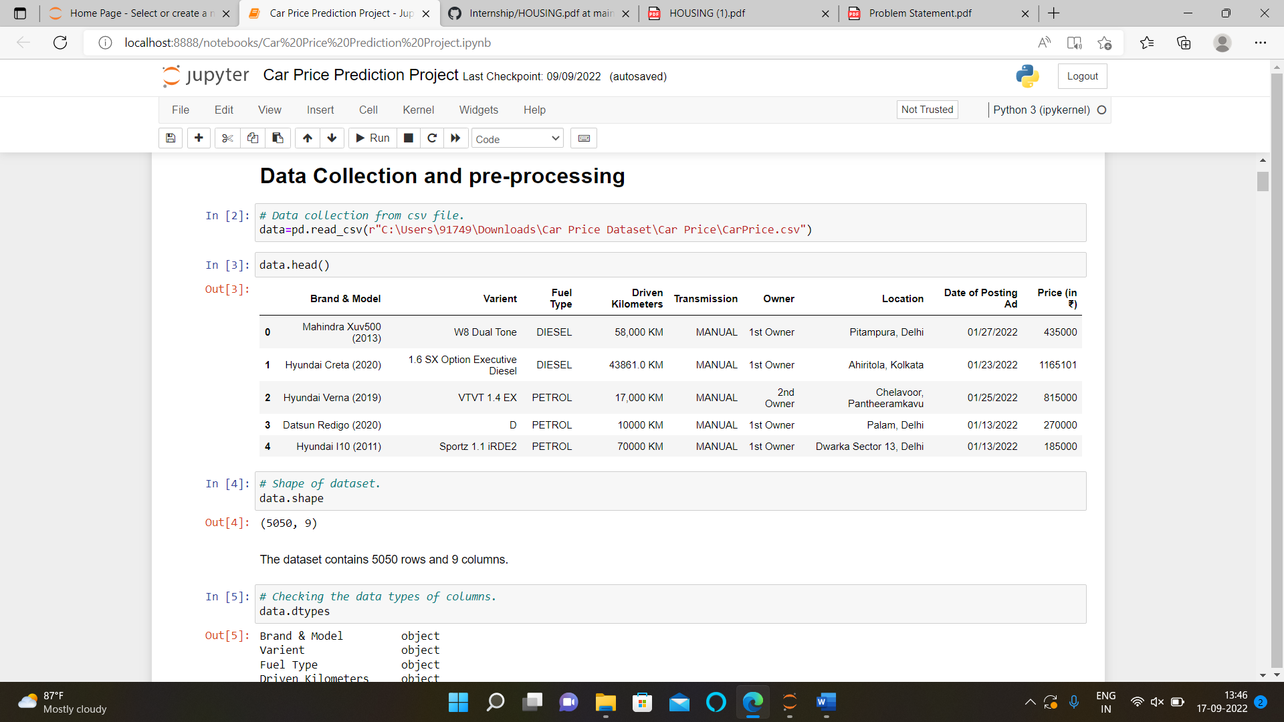

• Data Pre-processing Done
The dataset contains object data type columns, missing values, I have treated them with ordinal encoding, and with mean and mode imputation.

• Hardware and Software Requirements and Tools Used
Here for this project, I used Jupyter notebook and tools used pandas and NumPy for mathematical operations, matplotlib and seaborn for various type of data visualizations

• Identification of possible problem-solving approaches (methods)
The statistical summary shows the total count of 1168 rows then mean, min value, max value, standard deviation and quartiles shows up and down values that means the data contains outliers.
• Testing of Identified Approaches (Algorithms)
- Linear Regression
- Random Forest Regressor
- Support Vector Regressor
- 5. Gradient Boosting Regressor
- 6. AdaBoost Regressor
- 7. Extra Trees Regressor 8. SGD Regressor

- Run and evaluate selected models
Linear regression algorithm shows a linear relationship between a dependent (y) and one or more independent (y) variables, hence called as linear regression. Since linear regression shows the linear relationship, which means it finds how the value of the dependent variable is changing according to the value of the independent variable.

Random Forest is a popular machine learning algorithm that belongs to the supervised learning technique. It can be used for both Classification and Regression problems in ML. It is based on the concept of ensemble learning, which is a process of combining multiple classifiers to solve a complex problem and to improve the performance of the model.

Gradient Boosting Regression is an analytical technique that is designed to explore the relationship between two or more variables (X, and Y).
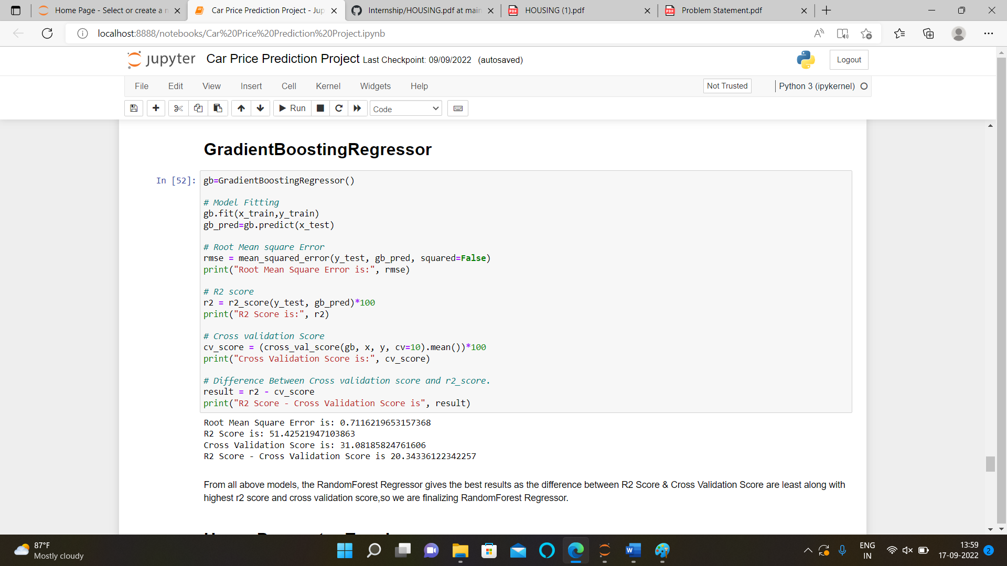

Support Vector Regression as the name suggests is a regression algorithm that supports both linear and non-linear regressions.

An extra-trees regressor. This class implements a meta estimator that fits a number of randomized decision trees (a.k.a. extra-trees) on various sub-samples of the dataset and uses averaging to improve the predictive accuracy and control over-fitting.

An AdaBoost regressor is a meta-estimator that begins by fitting a regressor on the original dataset and then fits additional copies of the regressor on the same dataset but where the weights of instances are adjusted according to the error of the current prediction.

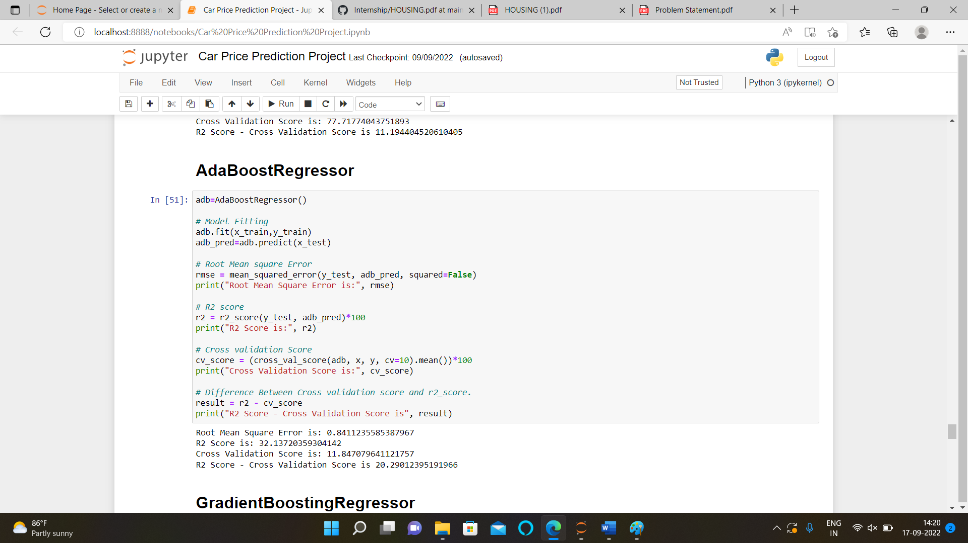

SGD stands for Stochastic Gradient Descent: the gradient of the loss is estimated each sample at a time and the model is updated along the way with a decreasing strength schedule (aka learning rate).

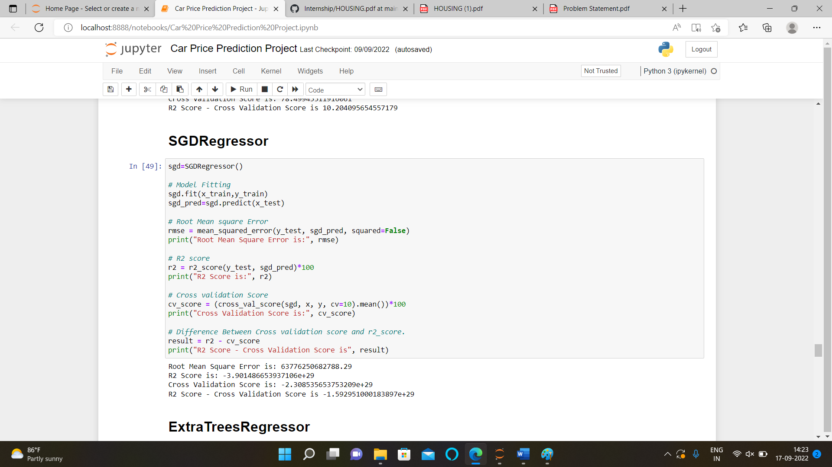

• Key Metrics for success in solving problem under consideration
A company's units can use these dashboards to create milestones and monitor their progress by tracking all the most relevant metrics in one location.

• Visualizations

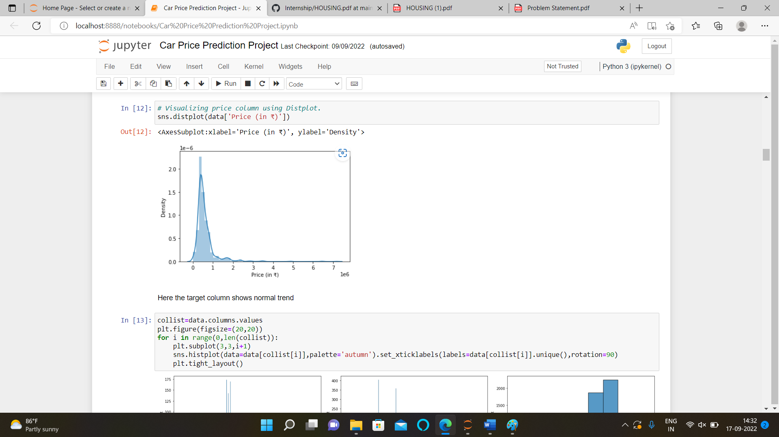

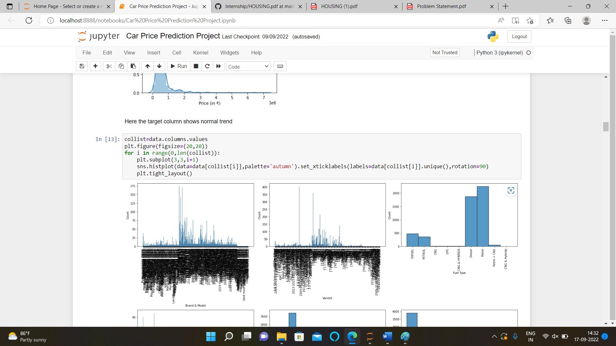

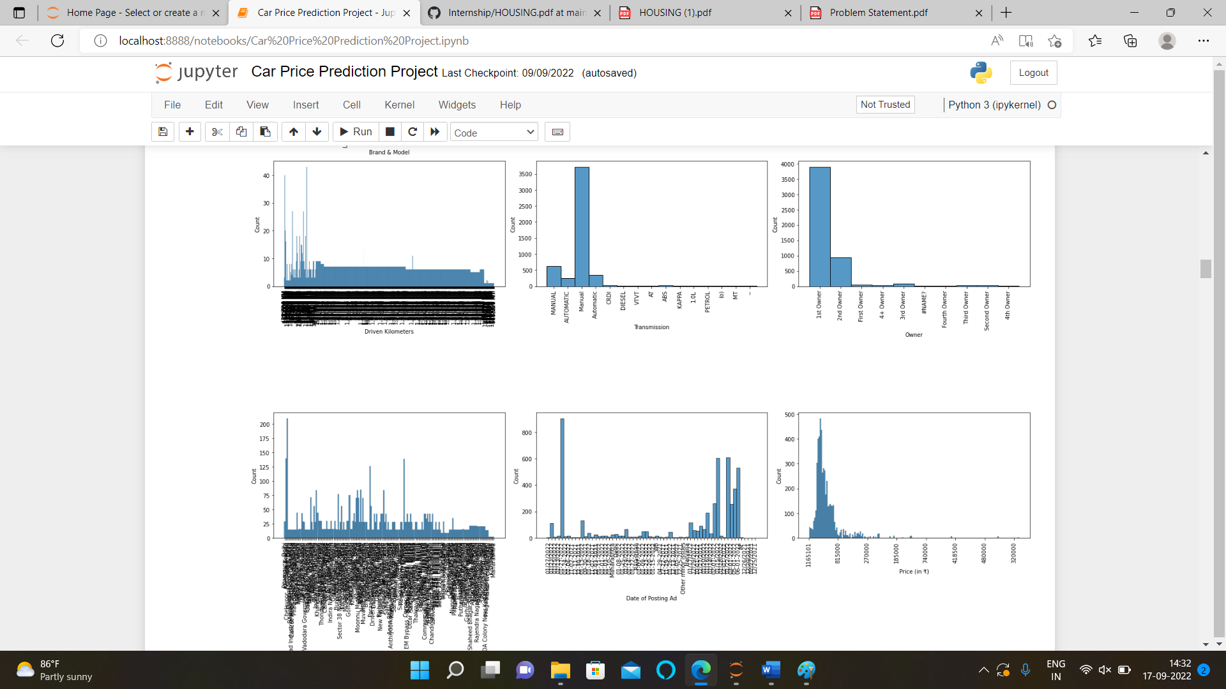

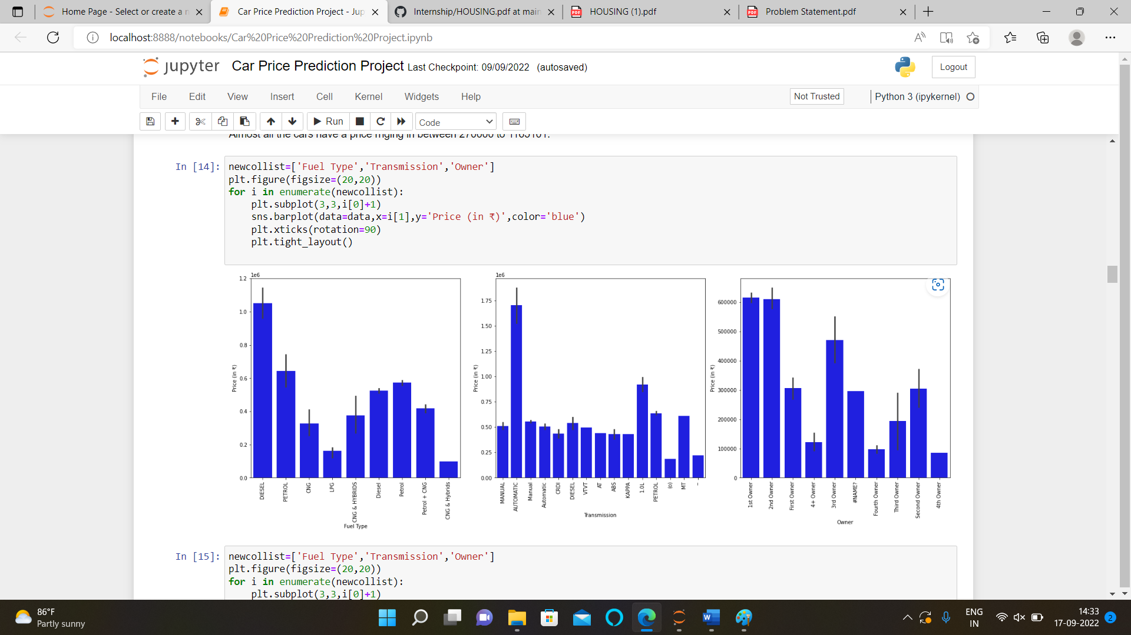

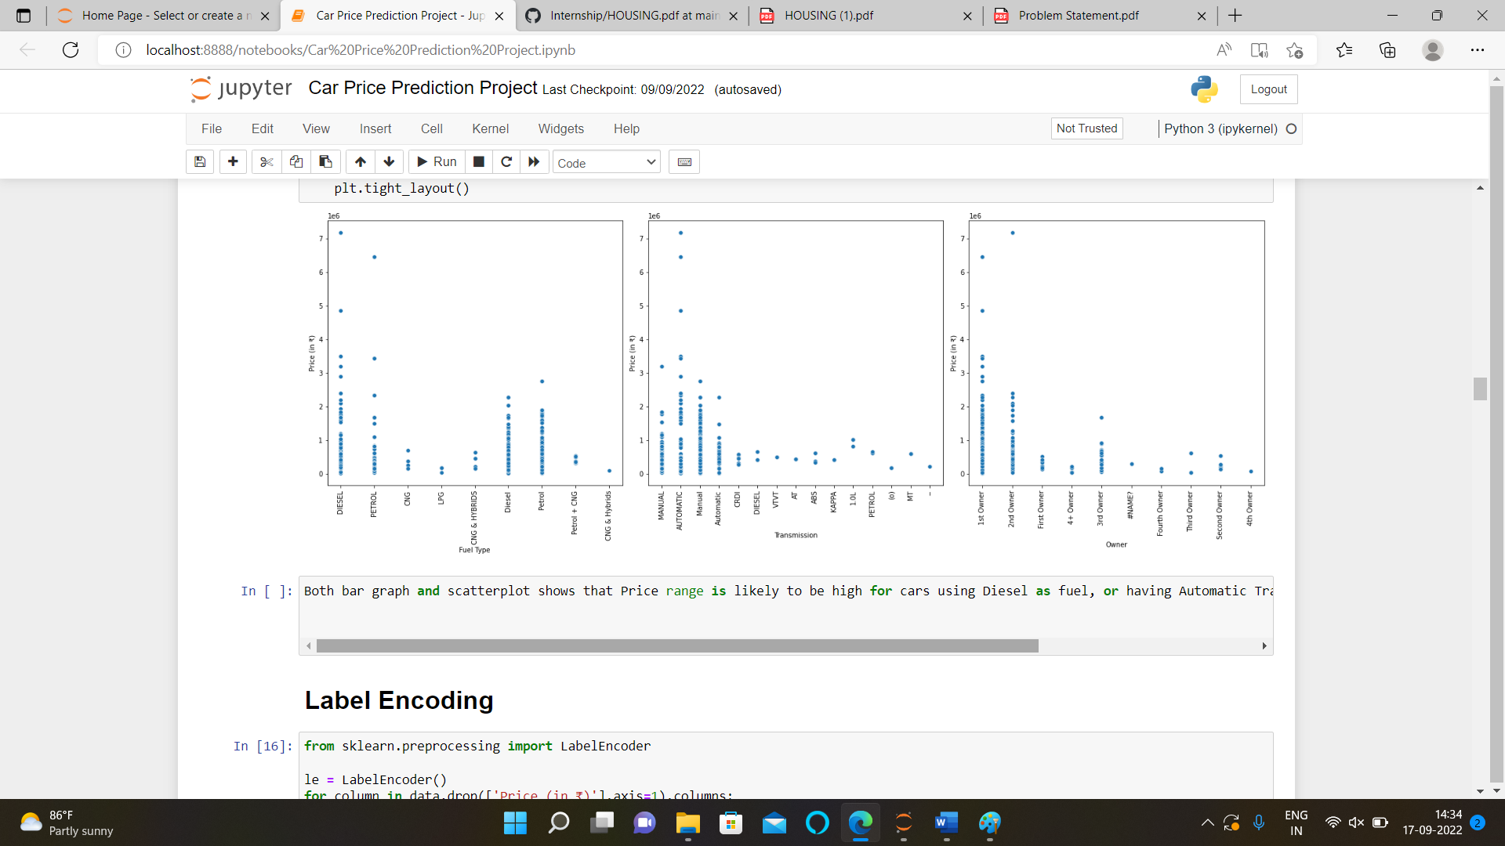

Observations

Brands, Variants, Driven Kilometres & Location columns have high no of values.
Maximum Cars run on either Petrol or diesel. Only few goes for CNG and other fuels.
Maximum Cars have Manual transmission.
Maximum cars are being sold by their very 1st Owner.
We have collected the cars posted online in last one month, from 25th December 2021 to 27th January 2022.
Almost all the cars have a price ranging in between 270000 to 1165101.

• Interpretation of the Results
Here after pre-processing we get the data encoded for framing the model and after visualization, we observe that the data contains skewness and we removed it using power transformation (yeo-john method), After checking correlation, we observe that the dataset don’t contain multicollinearity. After data pre-processing and EDA we build 6 different algorithms for dataset and from them Random Forest Regressor algorithm perform very well , Lastly we perform hyper parameter tunning to enhance the r2 score. Here we finalise the Random Forest Regressor algorithm as our best fit model.

